- Execute all the templates shown in video.

Created a main.tf file , and perform “terraform init” , it creates a “.terraform” directory consists of required dependencies , and plugins .
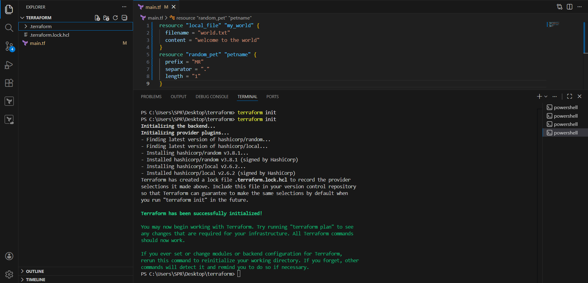
perform “terraform plan” to check what the changes going to be made.
Perform “terraform apply ’
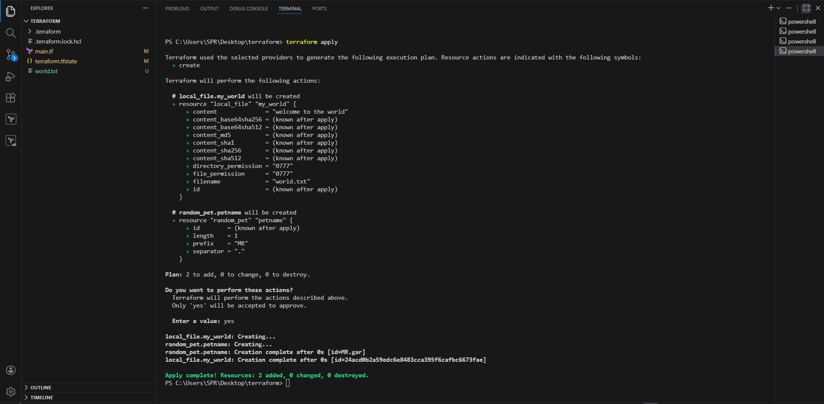
it created the file as per maint.tf , and aslo creates “terraform.statefile” , which is blueprint of the infrastructure .

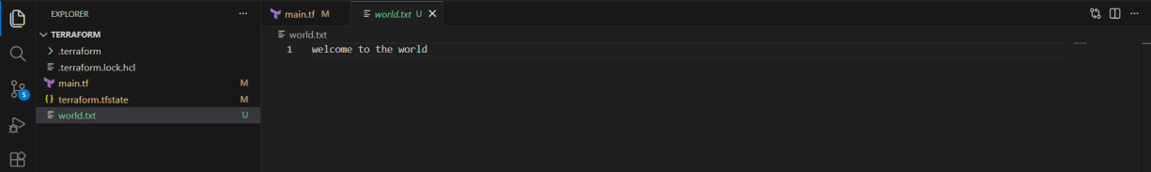
LIFECYCLE RULES :

- Create_before_destroy : We can configure lifecycle rules to our resource file, Terraform will destroy the file before creating a new file by default.
We can create a file before destroy by using the lifecycle rule.
We need to add lifecyle rule in “main.tf”
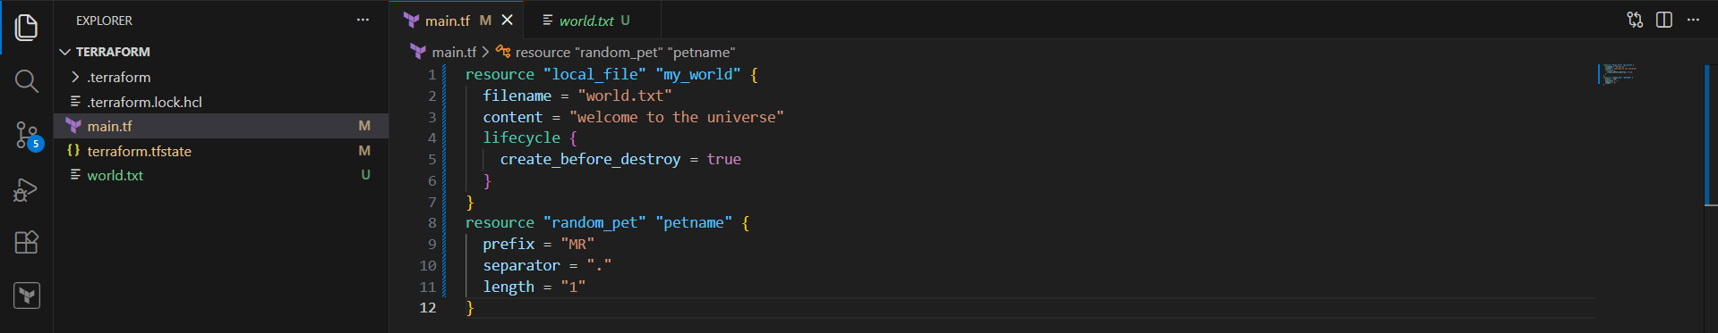
Now perform terraform apply .

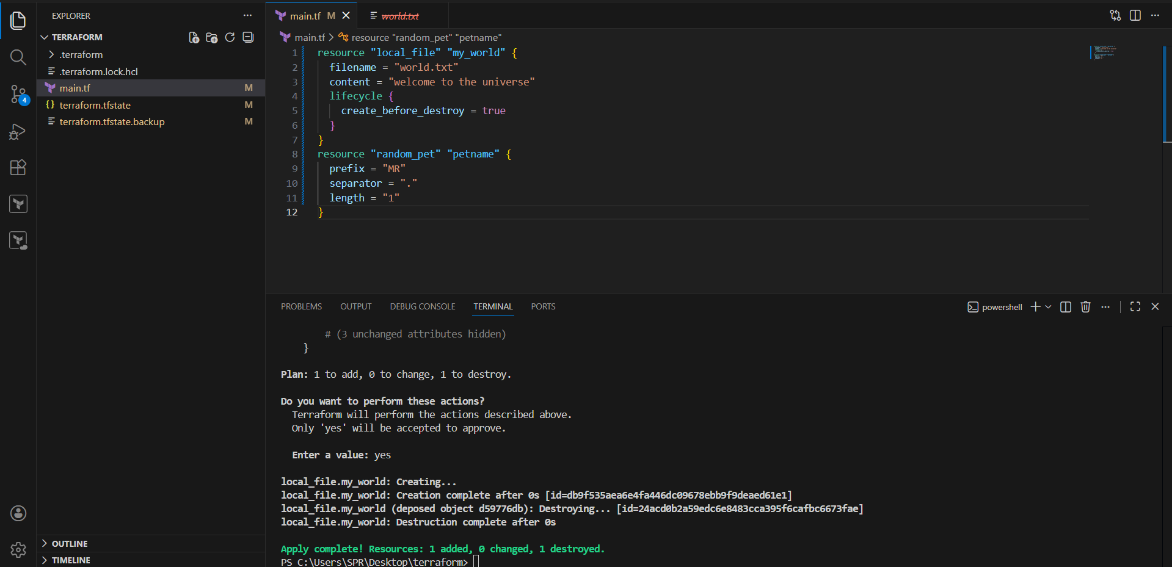
We can see that it is creating first and destroy next.

- Prevent_destroy : if we dont want to delete for any reason this lifecycle is used

Add this lifecyle in “main.tf” , perform terraform apply , it shows instance cannnot be destroyed.

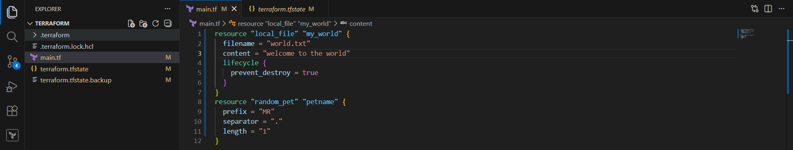
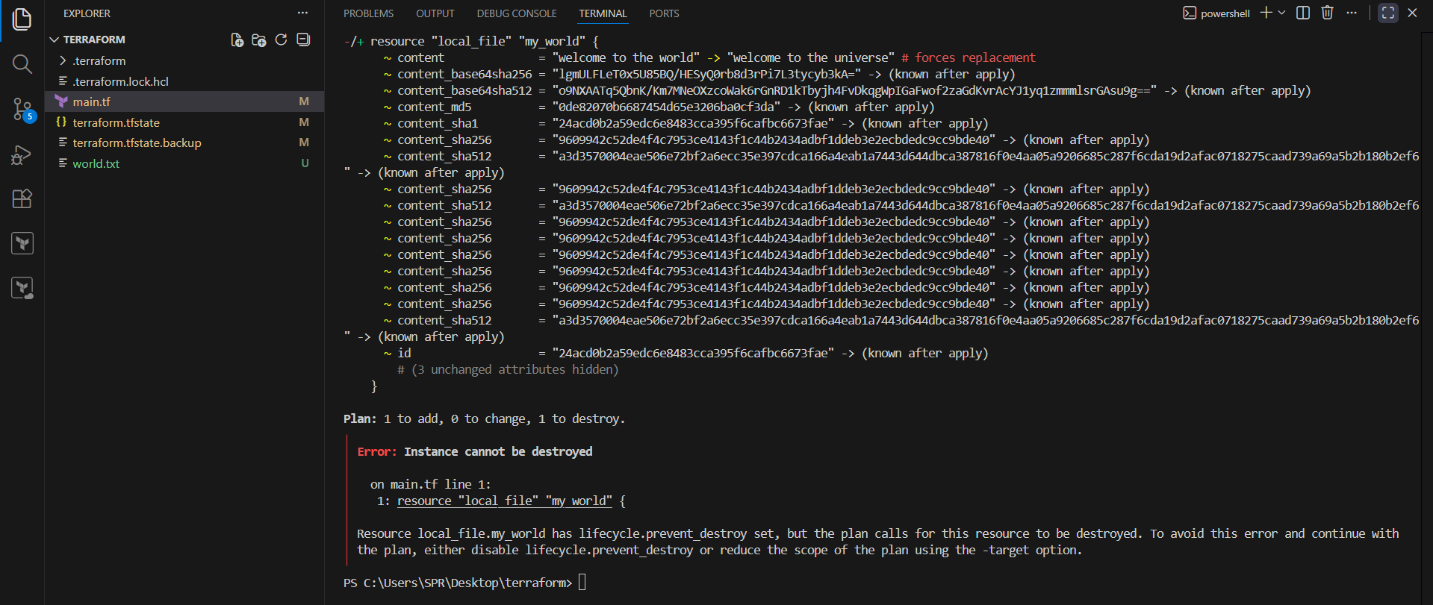
- Ignore_Change : If we want to ignore the changes which has been by third party tool or manually then we can use the ignore_change.

Add lifecycle rule in main.tf ., and changed content= welcome to world ., ignored changes for the attribute content.

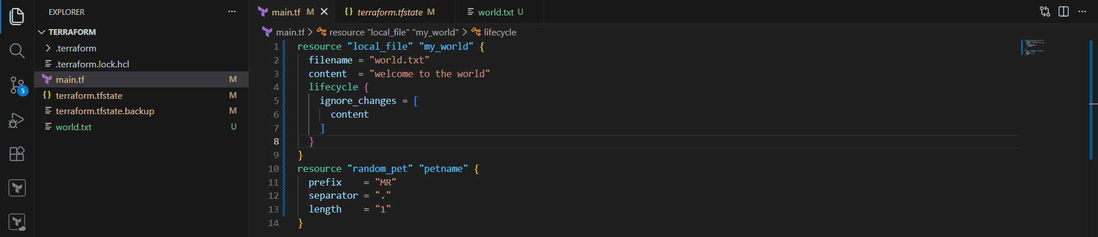
Terraform.statefile
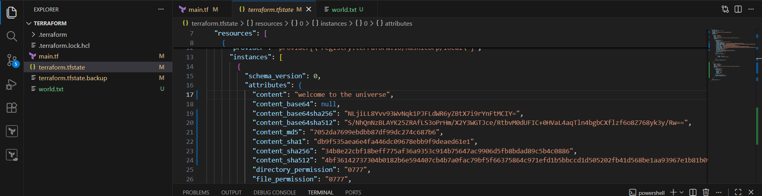
Now perform terraform apply .
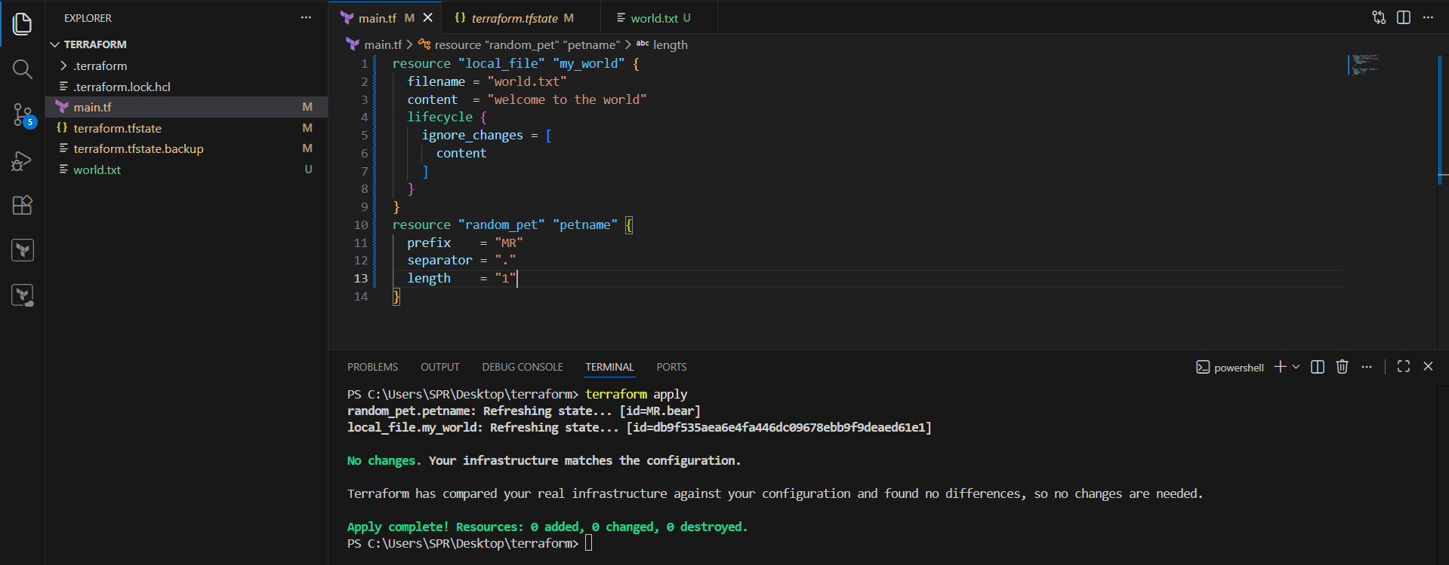
It shows that no changes to be made , it ignored the changes and gives output from statefile.

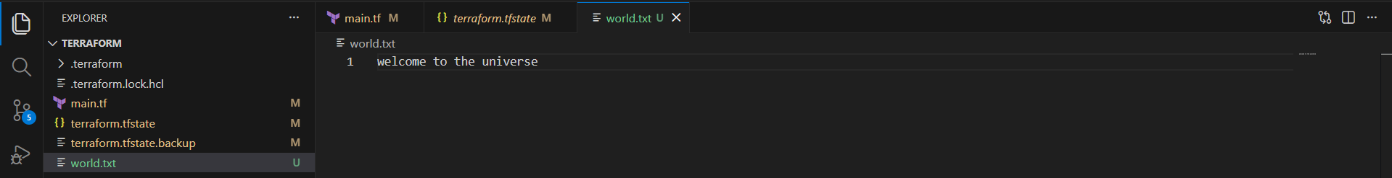

VARIABLES : Instead of hardcoding all the variables in the same configuration file we can use variables so that it can be
reuse again and again by only changing the variables file.

variable block:
==============
variable "filename" {
default ="root/pets.txt" --> Default value
type = --> type of variable
description = --> "message"optional but can define why the varible is used for
}

Type of variable Example
String I love pets
Number 1
bool true/false
any default value
list ["cat","dog"]
map pet1= cat
pet2=dog
object complex data structure
tuple complex data structure

Create new file named “variable.tf”

Case 1) adding variable blocks with values .
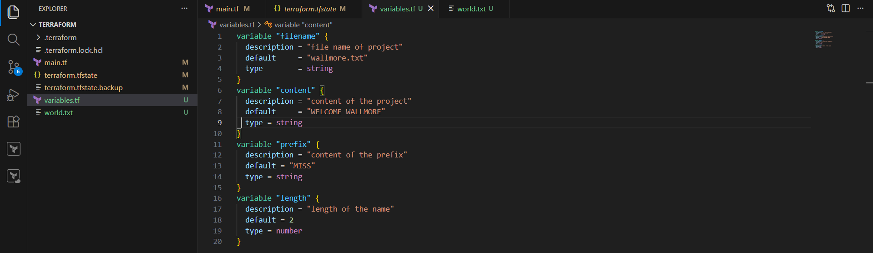
Modified the main.tf file , call the variables. Syntax { var.variable_name }
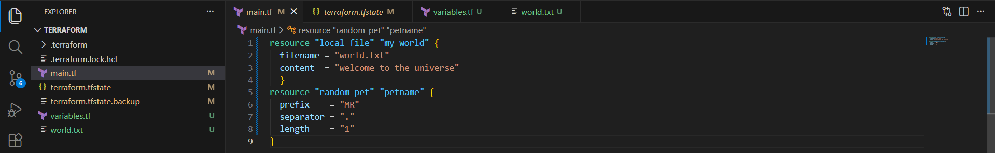
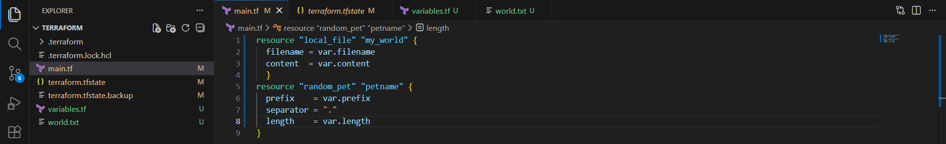
Terraform apply

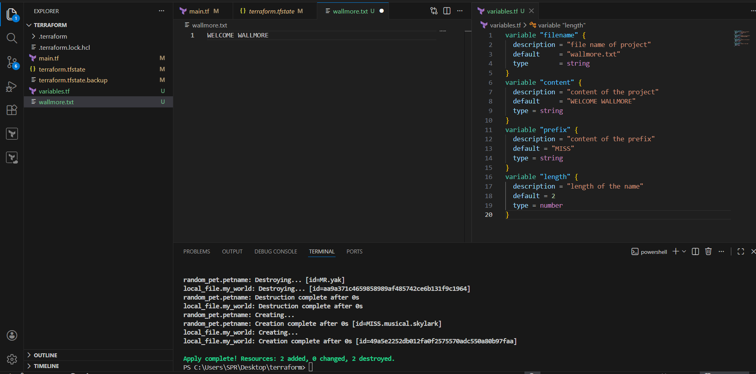
It creates the file as per vaiables.tf file

Case 2) adding empty variable blocks : by creating empty blocks , user need to pass the values directly for the variables , after performing terraform apply.
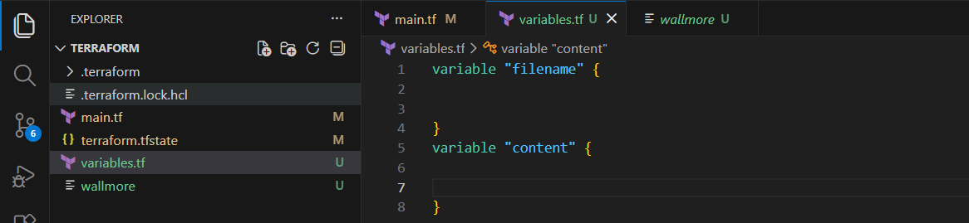
And also changed “main.tf”
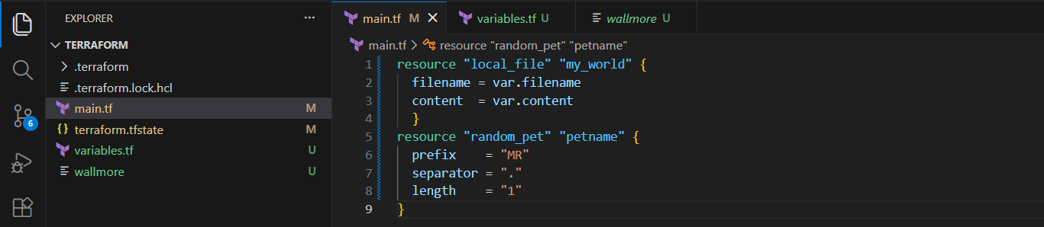
Terraform apply .,

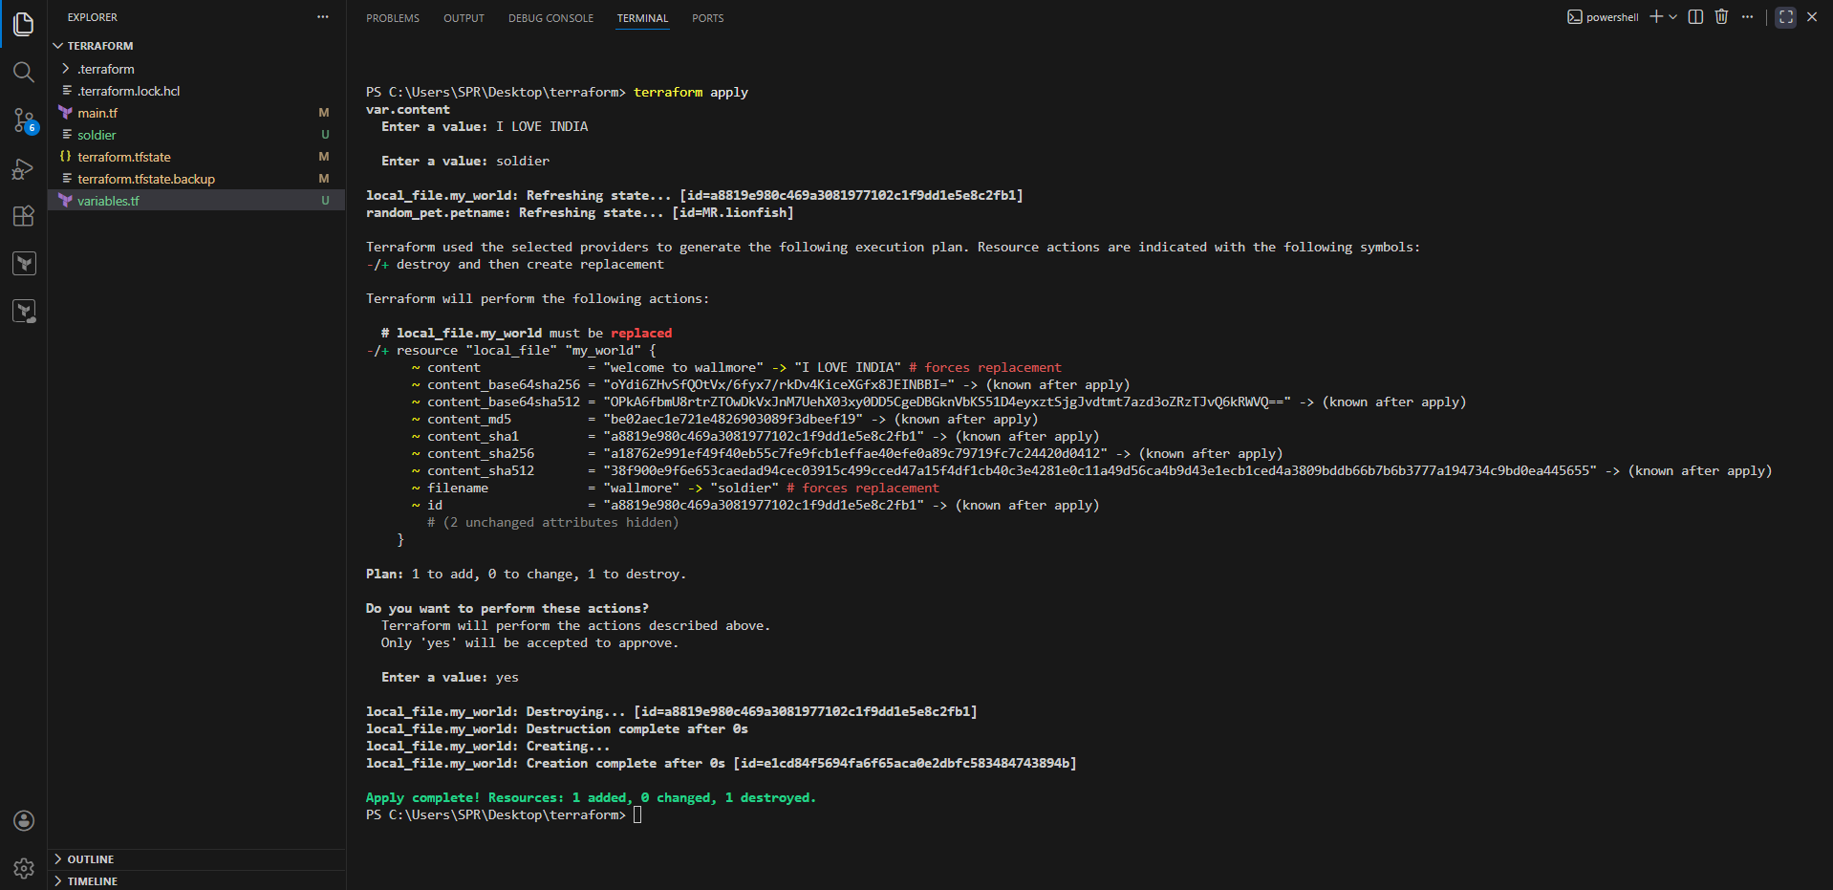
file created as per inputed values.
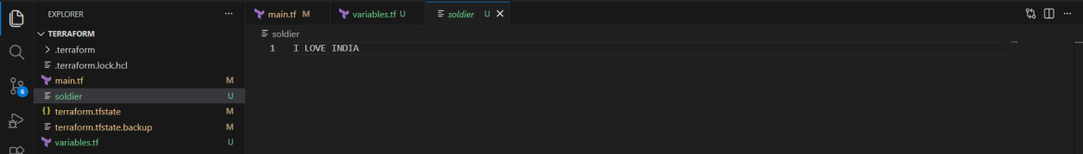
Case 3) we can pass the variables directly in command line flags .

Syntax : terraform apply -var “filename=wild.txt” -var “content=Welcome to jurrasic park”

Note there should be no space in “filename=wild.txt”.

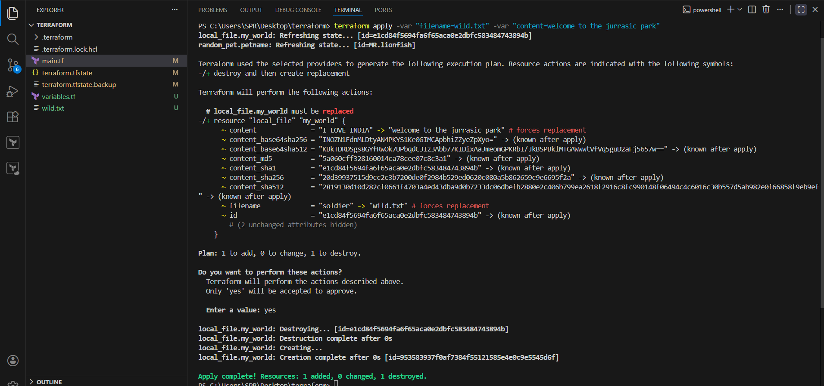
As per the values passed file got created.
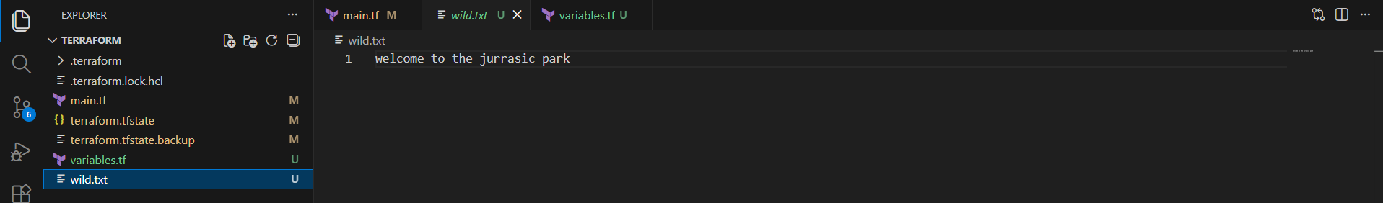
- Integrate terraform in Jenkins using Terraform plugin.

1. Prerequisites

Before starting, ensure the following are in place:

### Infrastructure & Software

* Jenkins installed and running
* Java (JDK 11 or 17 recommended)
* Terraform installed on Jenkins server **OR** use Terraform via Jenkins plugin
* Git installed on Jenkins server
* Access to a cloud provider (AWS / Azure / GCP)

### Jenkins Requirements

* Admin access to Jenkins
* Required Jenkins plugins:

* **Terraform Plugin**
* **Git Plugin**
* **Pipeline Plugin**
* **Credentials Binding Plugin**

### Source code management

* Git repository with Terraform code (main.tf, variables.tf, etc.)

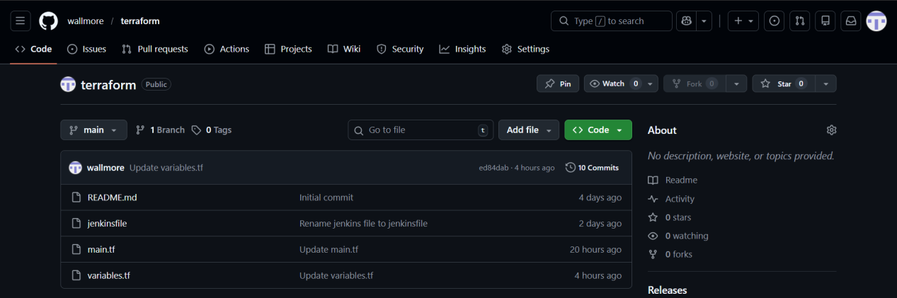

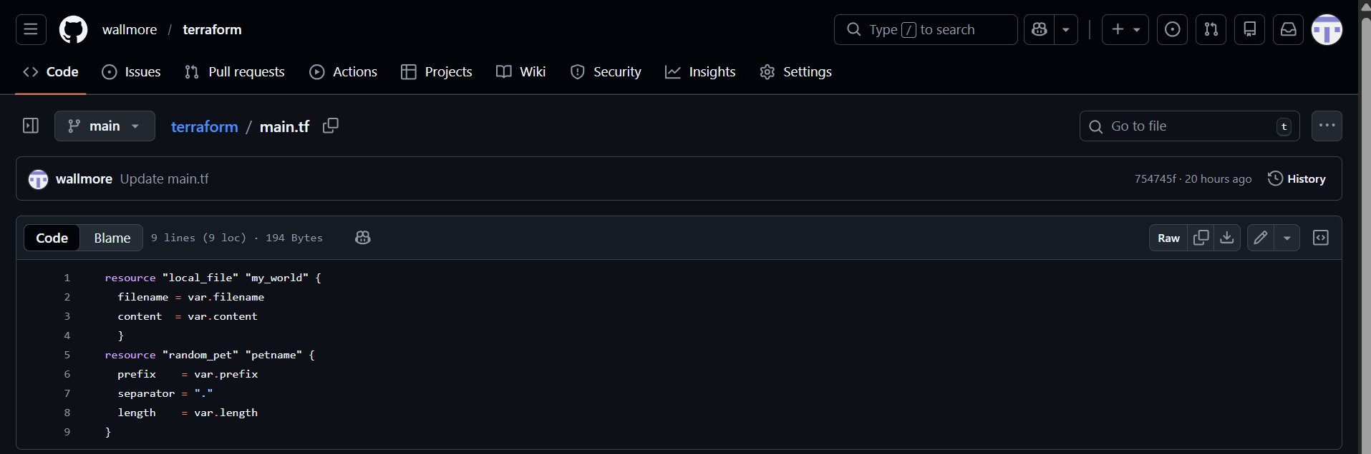

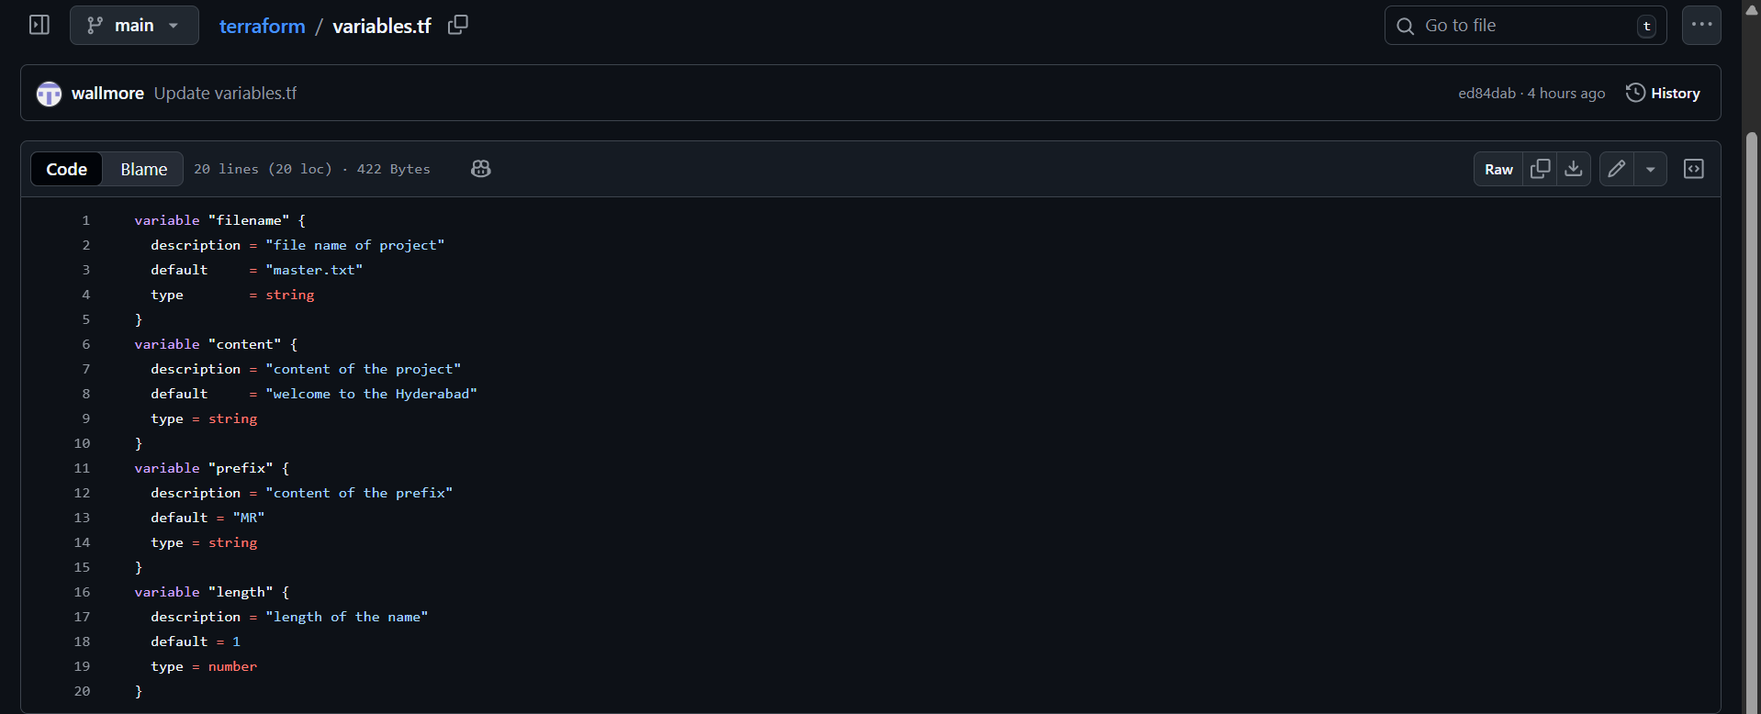

2. Step-by-Step Implementation

### Step 1: Install Terraform , pipeline-stageview , git Plugin in Jenkins

1. Login to Jenkins → **Manage Jenkins** → **Manage Plugins**
2. Go to **Available**
3. Search for **Terraform Plugin , pipeline-stageview , git**
4. Install and restart Jenkins

### Step 2: Configure Terraform Tool in Jenkins

1. Go to **Manage Jenkins** → **Global Tool Configuration**
2. Scroll to **Terraform**
3. Click **Add Terraform**
4. Provide:

* Name: `terraform`
* Install automatically (recommended) OR provide local Terraform path
5. Save

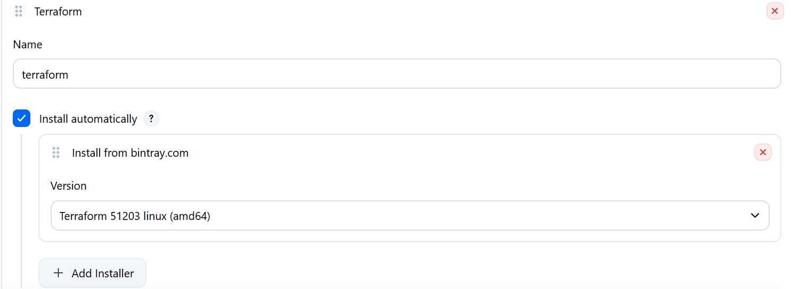

### Step 3: Add Cloud Credentials in Jenkins

1. Go to **Manage Jenkins** → **Credentials**
2. Add new credentials:

* Kind: aws_credentials / acceskeyid & secret-accesskey
* ID: `aws-creds` (example)
3. Save

### Step 4: Create Jenkins Pipeline Job

1. Go to Jenkins Dashboard → **New Item**
2. Select **Pipeline**
3. Name it: `terraform-pipeline`

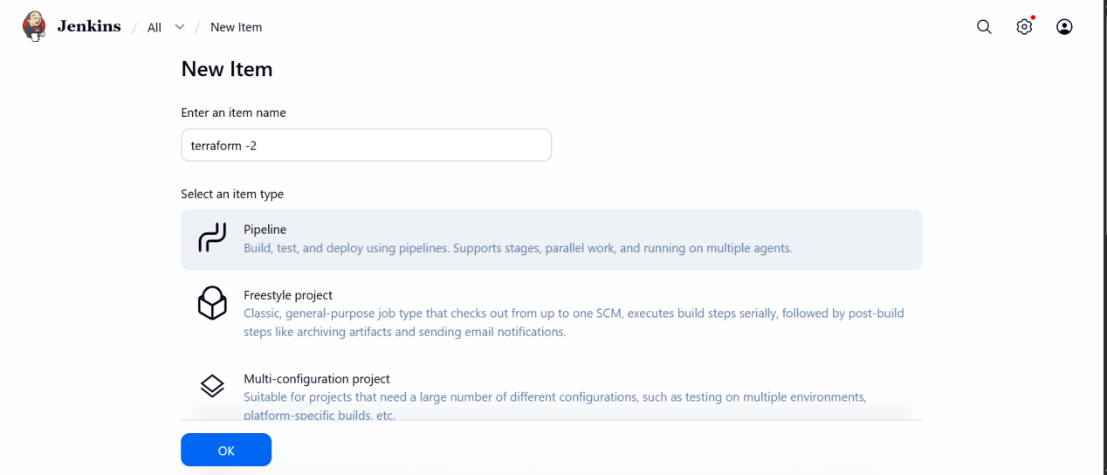
### Step 5: Jenkinsfile (Pipeline Script)

Create a `Jenkinsfile` in your Git repo:

pipeline{
agent any
tools {
terraform 'terraform'
}
environment {
GIT_URL = "https://github.com/wallmore/terraform.git"
GIT_BRANCH = "main"
}
stages {
stage('git-clone'){
steps {
git branch:"${GIT_BRANCH}",
url:"${GIT_URL}"
}
}
stage('terraform-init'){
steps {
sh 'terraform init'
}
}
stage('terraform-plan'){
steps {
sh 'terraform plan'
}
}
stage('terraform-apply'){
steps {
sh 'terraform apply -auto-approve'
}
}
}
}

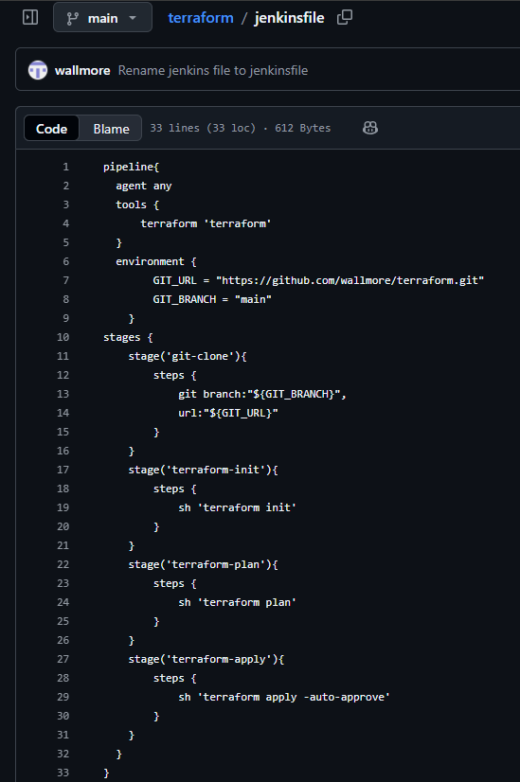

### Step 6: Configure Git Repository in Jenkins Job

* In Pipeline job:

* Definition: **Pipeline script from SCM**
* SCM: Git
* Repository URL: your Terraform repo
* Branch: main
* Script Path: jenkinsfile

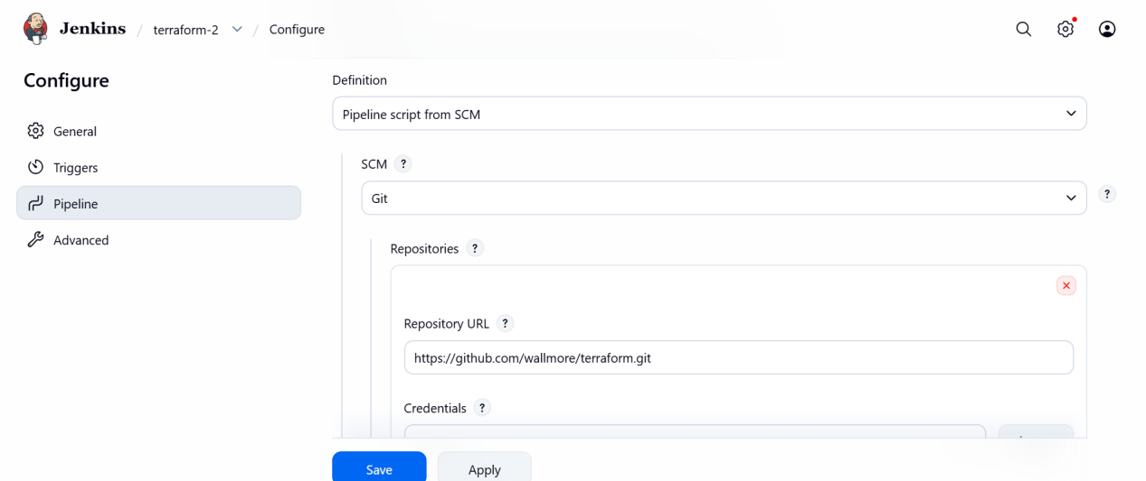
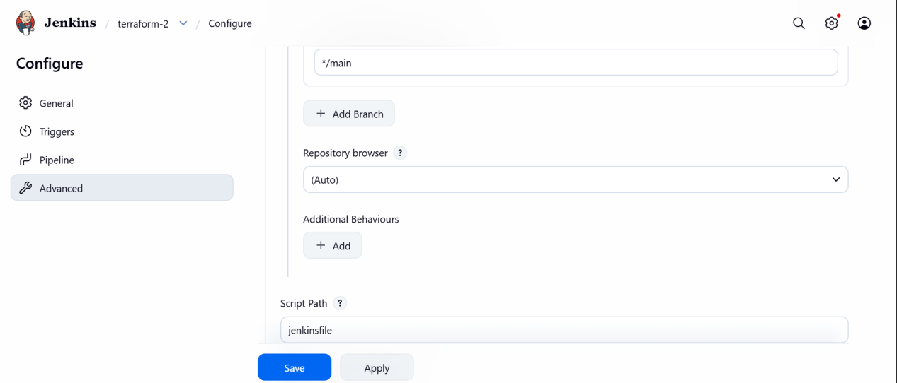

### Step 7: Build the Job

Click **Build Now** to trigger the pipeline.

3. Validation Steps

### Validation 1: Jenkins Console Output

Check Jenkins build logs for:

* `terraform init` completed successfully
* `terraform validate` passed
* `terraform plan` generated
* `terraform apply` executed without errors

### Validation 2: Terraform State

Verify:

* `terraform.tfstate` created (locally or in remote backend like S3)

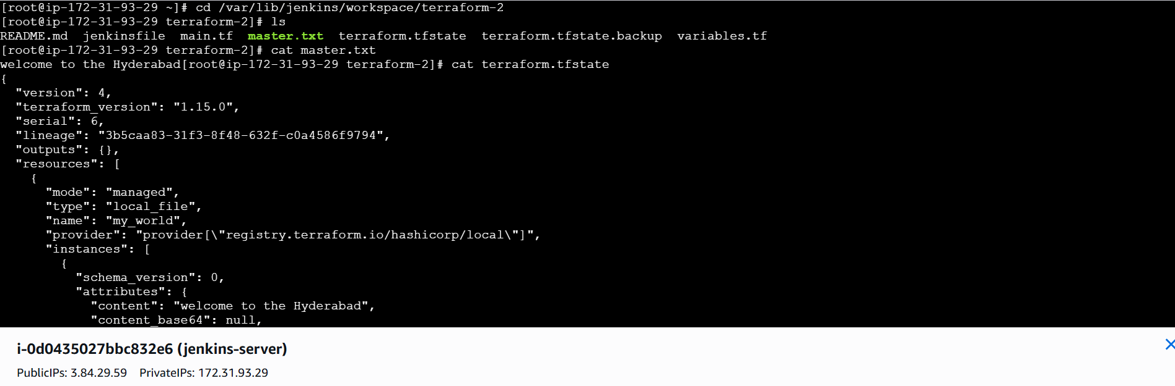

### Validation 4: Jenkins UI

* Job status should be **SUCCESS**
* All stages should be green

